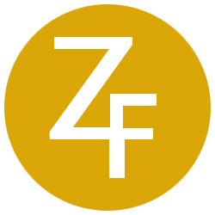

PHOTO RELEASE Contact: John Xuereb
610-520-6140 X202
jxuereb@alvare.com

Coach Ron Fraser, “The Wizard of College Baseball,”
Immortalized in Bronze

Statue of Coach Ron Fraser, created by world-renowned sculptor Zenos Frudakis, unveiled in a dedication ceremony on Friday, April 24, at Alex Rodriguez Park at Mark Light Field

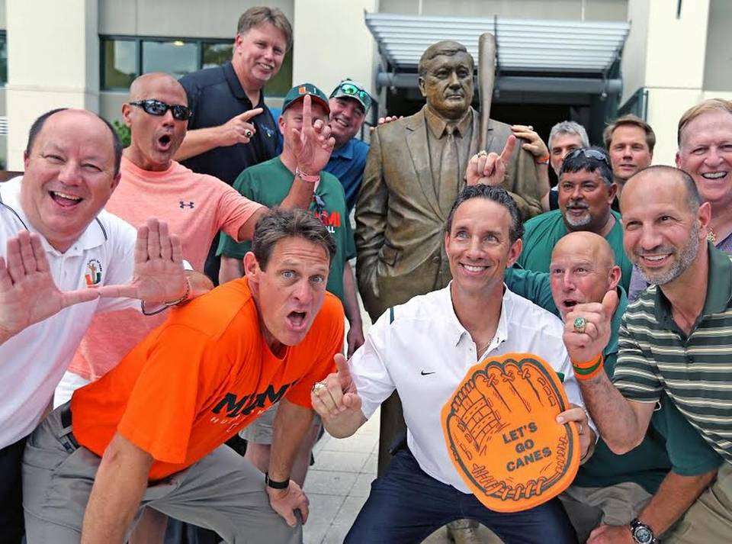
Former University of Miami Hurricanes team members gather round the statue of Ron Fraser (1933-2013),
The Wizard of College Baseball, at the unveiling ceremony on April 24, 2015.

MIAMI, Fla. -- April 24, 2015 -- A 7-foot, 500-pound bronze statue of former University of Miami Hurricanes coach Ron Fraser was unveiled on April 24, in a free public dedication ceremony outside of the Alex Rodriguez Park at Mark Light Field, on the campus of the University of Miami.
The monument to “The Wizard of College Baseball,” who led the Hurricanes for 30 years from 1963-92, was created in clay by world-renowned, Philadelphia-based sculptor Zenos Frudakis and cast in bronze at the Laran Bronze Foundry in Chester, Pa. The statue was majorly funded by friends and fans of the late Coach Fraser and was completed within a year.
Coach Ron Fraser, who passed away in 2013, was one of the most successful coaches in NCAA baseball history, and was responsible for bringing college baseball to a new level of public awareness. While never posting a losing season, Fraser’s teams won 1,271 games and captured the 1982 and 1985 national titles.
From ESPN covering games in Miami to his "Dinner on the Diamond," from creating the batgirls with "The Sugarcanes" to developing a mascot, The Miami Maniac, Fraser made Mark Light Stadium the premier family entertainment spot in South Florida. More than a hundred of Fraser's ballplayers went on to professional baseball and many more started successful careers. Fraser was inducted into the College Baseball Hall of Fame in its introductory Class of 2006.
Among his more than 100 monumental public and private works, Zenos Frudakis has sculpted more than a dozen works of local and national sports figures, including, by alphabetical order, Richie Ashburn, Steve Carlton, Joe DiMaggio, Bobby Jones, Jack Nicklaus, Danny Murtaugh, Arnold Palmer, Robin Roberts, Mike Schmidt, Dan "Lake" Staffieri, and Payne Stewart. http://zenosfrudakis.com/sculptures/sports/index.html
About Zenos Frudakis
Philadelphia-based sculptor Zenos Frudakis has been called the “American Rodin.” He has been a professional working sculptor for nearly four decades, and in that time has created more than 100 monumental works in public and private collections throughout the US and abroad. By scholarship he attended Pennsylvania Academy of the Fine Arts. He earned a Bachelor of Fine Arts degree and a Master in Fine Art from the University of Pennsylvania. Zenos' emphasis has been the figure and the portrait, as demonstrated in his many monumental figure/portrait works, individual portrait busts and bas-reliefs. He excels at expressing the character and vitality of his subjects while capturing an accurate likeness. Zenos portfolio includes figure sculpture, animals, bas-reliefs, portraits -- both busts and paintings -of living and historical individuals, and poetic/philosophical sculpture with a post-modern sensibility.. www.zenosfrudakis.com

# # #

